ABSTRACT [Title]
(Bold, 12 point, Times or Times New Roman)
First Name SURNAME¹, First Name SURNAME²,
1- Affiliation, Address, Zip Code, Country, e-mail, …
Corresponding author: e-mail
(10 point, Times or Times New Roman)

Keywords: Tritium separation, detritiation, fusion reactors, measurement and monitoring, decontamination and waste management, etc.
Please present an accurate account of the researches performed as well as an objective discussion of their significance. Please ensure that your original works are concisely and accurately presented but with sufficient detail and references.
The page length must be one page including figures and tables.
The pictures, graphs, and illustrations rresolution should be at least 300 dpi. Figure captions should be placed below the figures with Arabic numbers – Figure 1. Use a blank line between the text and the figures.
Table captions should be placed above the tables with Arabic numbers - Table I. Place a blank line between the text and the tables.
The references will be listed at the end of the paper. The reference must be inserted in the text like [1], [1,2] and [1, 5-8].

[1] R. Gangradey, et al., Fusion Science and Technology Volume 77, pages 333-339, 2021, Issue 5
[2] A. Brem, et al., Cryogenics, Volume 115, pages 333-339, 2021, 103260.

Table 1. ………………………………. (10 point, Times or Times New Roman)
xxx | xxx | xxx | xxx | xxx | xxx | xxx | xxx
1
2

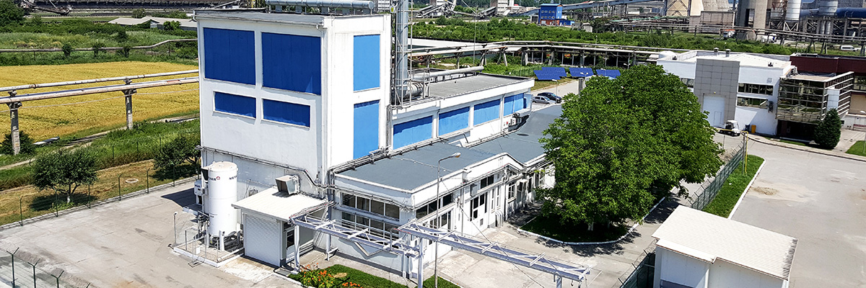
Figure 1 - Pilot Plant for Tritium and Deuterium Separation – ICSI Rm.Valcea

